**Assignment 04 – HMM POS tagging**

***Chentai Yuan, Qianzhong Chen, Hao Ding***

***ECE448, Group 07***

***TA: Shuting Tao, Hanrong Zhang***

***May 15, 2023***

**Section Ⅰ: Baseline**



**Section Ⅱ: Viterbi_1**



**Section Ⅲ: Viterbi_2**

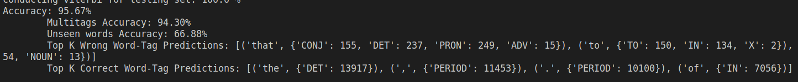

**Section Ⅳ: Viterbi_ec**

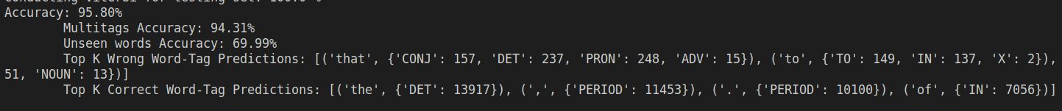

In this section, we built a suffix & Prefix set includes [X_ING, X_ED, X_LY, UN_X, IN_X]. From hapax word set, we count the probability of P(tag | fix), i.e., if a prefix or suffix is detected from an unknown word, the probability that the word has a certain tag. As we chose the prefix and suffix that are widely used, our new algorithm has achieved satisfied prediction performance.

**ACKNOWLEGEMENTS**

Qianzhong Chen wrote his own version of baseline.py, Viterbi_1.py, Viterbi_2.py, Viterbi_ec.py, and amend the provided Viterbi_1.py file.

Chentai Yuan try to debug with the Viterbi_1.py and Viterbi_2.py.

Hao Ding assist on writing the Viterbi_1.py, Viterbi_2.py.